Step 1: Go to www.shelbycountyyap.org

Step 2: Click on the yellow donate button in the top right hand corner of the screen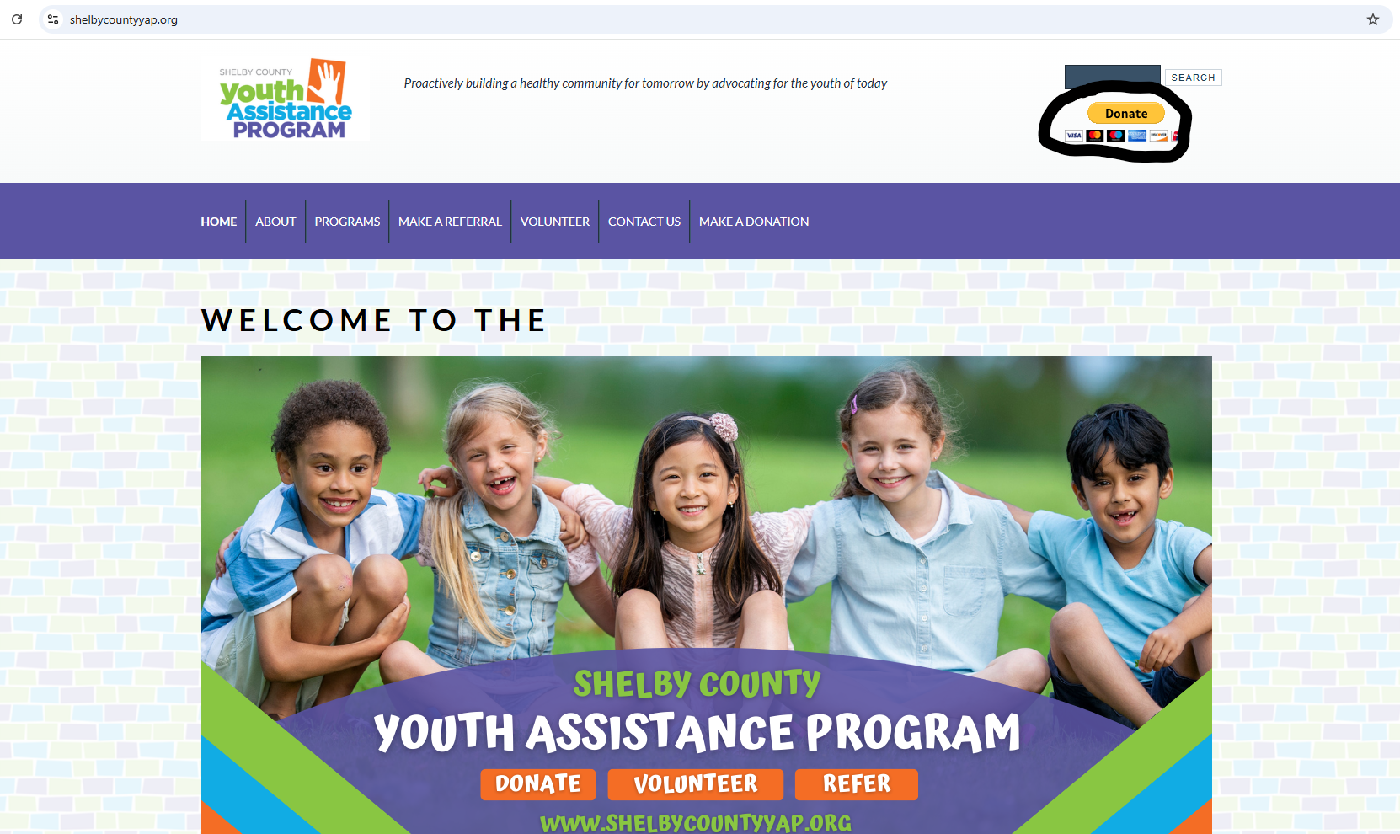

Step 3: Enter the amount you would like to donate and select Donate with PayPal or Donate with Credit/Debit Card
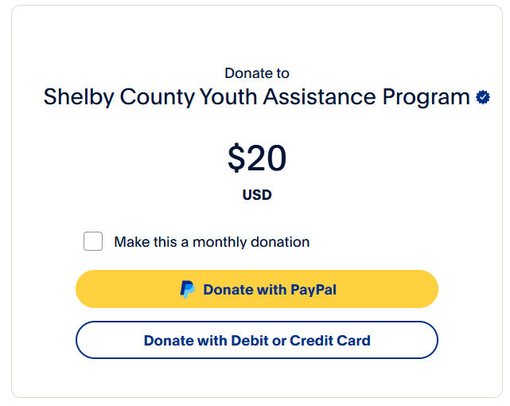
Step 4: Donate with PayPal. It will prompt you to connect to your PayPal account.
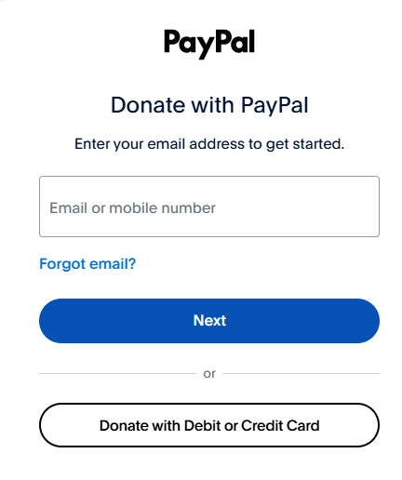
Donate with Credit or Debit Card: Fill in the information completely and select Donate Now.
